Picket Style

Alton™
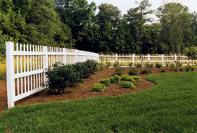
The ambience of wrought iron.
If you like picket fence, this series is certain to have a style you desire. The Alton provides the ultimate in picket fence simplicity, certain not to hide your favorite flowers and shrubs. The Brighton includes an intermediate height picket for greater decor . . . and the Clayton offers a similar design with a full height picket. If you would like some flair, look at the unique Dalton Series. This family of styles is sturdy, economical, and provides the ambience of the old wrought iron fence.
The Alton offers the cleanliness of a single, full height picket design.
- Standard Height Options: 48", 60", or 72"
- Post Spacing Options: 4' or 6' center-to-center
- Post Dimensions: 48" High Fence = 4" x 4" x 72" 60" High Fence = 4" x 4" x 96" 72" High Fence = 4" x 4" x 108"
- Standard Post Depth: 48" High Fence = 24" Post Depth 60" High Fence = 36" Post Depth 72" High Fence = 36" Post Depth
- Standard Cap Style: Click here to view post cap options.
- Horizontal Dimensions: 2" Thick x 3 1/2" Wide
- Picket Spacing/Picket Dem.: 5" / 1" x 1"
Ground Clearance: 2"

Brighton™
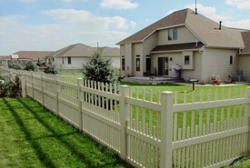
The ambience of wrought iron.
If you like picket fence, this series is certain to have a style you desire. The Alton provides the ultimate in picket fence simplicity, certain not to hide your favorite flowers and shrubs. The Brighton includes an intermediate height picket for greater decor . . . and the Clayton offers a similar design with a full height picket. If you would like some flair, look at the unique Dalton Series. This family of styles is sturdy, economical, and provides the ambience of the old wrought iron fence.

The Brighton combines a full height picket and a mid-height for an interesting pattern. Brighton works well to highlight a yard or protect a swimming pool without impairing visibility.
- Standard Height Options: 48", 60", or 72"
- Post Spacing Options: 4' or 6' center-to-center
- Post Dimensions: 48" High Fence = 4" x 4" x 72" 60" High Fence = 4" x 4" x 96" 72" High Fence = 4" x 4" x 108"
- Standard Post Depth: 48" High Fence = 24" Post Depth 60" High Fence = 36" Post Depth 72" High Fence = 36" Post Depth
- Standard Cap Style: Click here to see post cap options.
- Horizontal Dimensions: 2" Thick x 3 1/2" Wide
- Picket Spacing/Picket Dem.: 2" / 1" x 1"
Ground Clearance: 2"

Clayton™
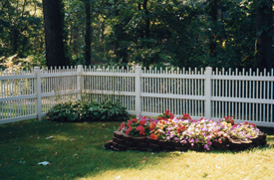
The ambience of wrought iron.
If you like picket fence, this series is certain to have a style you desire. The Alton provides the ultimate in picket fence simplicity, certain not to hide your favorite flowers and shrubs. The Brighton includes an intermediate height picket for greater decor . . . and the Clayton offers a similar design with a full height picket. If you would like some flair, look at the unique Dalton Series. This family of styles is sturdy, economical, and provides the ambience of the old wrought iron fence.

The Clayton utilizes alternating full height pickets. The Clayton is an attractive accent to many home styles.
- Standard Height Options: 48", 60", or 72"
- Post Spacing Options: 4' or 6' center-to-center
- Post Dimensions: 48" High Fence = 4" x 4" x 72" 60" High Fence = 4" x 4" x 96" 72" High Fence = 4" x 4" x 108"
- Standard Post Depth: 48" High Fence = 24" Post Depth 60" High Fence = 36" Post Depth 72" High Fence = 36" Post Depth
- Standard Cap Style: Click here to see post cap options.
- Horizontal Dimensions: 2" Thick x 3 1/2" Wide
- Picket Spacing/Picket Dem.: 2" / 1" x 1"
Ground Clearance: 2"

Dalton®
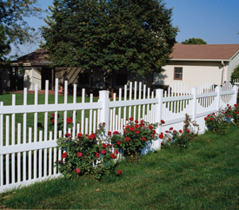
The ambience of wrought iron.
If you like picket fence, this series is certain to have a style you desire. The Alton provides the ultimate in picket fence simplicity, certain not to hide your favorite flowers and shrubs. The Brighton includes an intermediate heightpicket for greater decor . . . and the Clayton offers a similar design with a full height picket. If you would like some flair, look at the unique Dalton Series. This family of styles is sturdy, economical, and provides the ambience of the old wrought iron fence.

The Dalton makes a wonderful backdrop for flowers or climbing plants. U.S. Patent No. D380,557
- Standard Height Options: 48", 60", or 72"
- Post Spacing Options: 6' center-to-center
- Post Dimensions: 48" High Fence = 4" x 4" x 72" 60" High Fence = 4" x 4" x 96" 72" High Fence = 4" x 4" x 108"
- Standard Post Depth: 48" High Fence = 24" Post Depth 60" High Fence = 36" Post Depth 72" High Fence = 36" Post Depth
- Standard Cap Style: Click here to see post cap options.
- Horizontal Dimensions: 2" Thick x 3 1/2" Wide
- Picket Spacing/Picket Dem.: 2 1/8" / 1" x 1"
Ground Clearance: 2"

Arlington®
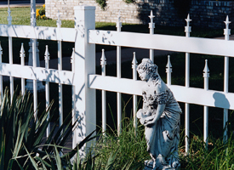
We call it the Back Bay Series.
This interesting group of fence styles is both ornate and elegant. A unique combination of verticals topped with Quad finials and/ or Fleur de lis caps.

Select the style that offers just the right amount of privacy and visibility . . . there is a style to fit your home.

A unique combination of alternating finials and caps.
- Standard Height Options: 48", 60", or 72"
- Post Spacing Options: 6' center-to-center
- Post Dimensions: 48" High Fence = 4" x 4" x 72" 60" High Fence = 4" x 4" x 96" 72" High Fence = 4" x 4" x 108"
- Standard Post Depth: 48" High Fence = 24" Post Depth 60" High Fence = 36" Post Depth 72" High Fence = 36" Post Depth
- Standard Cap Style: Click here to see post cap options.
- Horizontal Dimensions: 2" Thick x 3 1/2" Wide
- Picket Spacing/Picket Dem.: 4.75" / 1" x 1"
Ground Clearance: 2"

Clarendon®
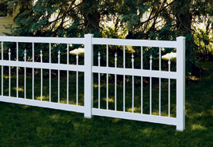
We call it the Back Bay Series.
This interesting group of fence styles is both ornate and elegant. A unique combination of verticals topped with Quad finials and/ or Fleur de lis caps.

Select the style that offers just the right amount of privacy and visibility . . . there is a style to fit your home.

The Clarendon features alternating verticals framed by strong horizontal rails.
- Standard Height Options: 48", 60", or 72"
- Post Spacing Options: 6' center-to-center
- Post Dimensions: 48" High Fence = 4" x 4" x 72" 60" High Fence = 4" x 4" x 96" 72" High Fence = 4" x 4" x 108"
- Standard Post Depth: 48" High Fence = 24" Post Depth 60" High Fence = 36" Post Depth 72" High Fence = 36" Post Depth
- Standard Cap Style: Click here to see post cap options.
- Horizontal Dimensions: 2" Thick x 3 1/2" Wide
- Picket Spacing/Picket Dem.: 4.75" / 1" x 1"
Ground Clearance: 2"

Dartmouth®
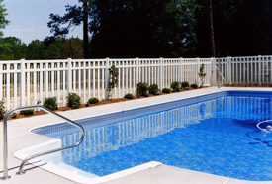
We call it the Back Bay Series.
This interesting group of fence styles is both ornate and elegant. A unique combination of verticals topped with Quad finials and/ or Fleur de lis caps.

Select the style that offers just the right amount of privacy and visibility . . . there is a style to fit your home.

The Dartmouth provides semi-privacy with a touch of Victorian tradition. Check with local building codes for pool enclosure regulations.
- Standard Height Options: 48", 60", or 72"
- Post Spacing Options: 6' center-to-center
- Post Dimensions: 48" High Fence = 4" x 4" x 72" 60" High Fence = 4" x 4" x 96" 72" High Fence = 4" x 4" x 108"
- Standard Post Depth: 48" High Fence = 24" Post Depth 60" High Fence = 36" Post Depth 72" High Fence = 36" Post Depth
- Standard Cap Style: Click here to see post cap options.
- Horizontal Dimensions: 2" Thick x 3 1/2" Wide
- Picket Spacing/Picket Dem.: 2" / 1" x 1" and 1" x 4"
Ground Clearance: 2"

Exeter®
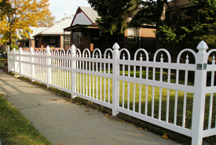
We call it the Back Bay Series.
This interesting group of fence styles is both ornate and elegant. A unique combination of verticals topped with Quad finials and/ or Fleur de lis caps.

Select the style that offers just the right amount of privacy and visibility . . . there is a style to fit your home.

The Exeter represents our most ornate Victorian style fence. It is perfect for the right setting.
- Standard Height Options: 48", 60", or 72"
- Post Spacing Options: 6' center-to-center
- Post Dimensions: 48" High Fence = 4" x 4" x 72" 60" High Fence = 4" x 4" x 96" 72" High Fence = 4" x 4" x 108"
- Standard Post Depth: 48" High Fence = 24" Post Depth 60" High Fence = 36" Post Depth 72" High Fence = 36" Post Depth
- Standard Cap Style: Click here to see post cap options.
- Horizontal Dimensions: 2" Thick x 3 1/2" Wide
- Picket Spacing/Picket Dem.: 5" / 1" x 1"
Ground Clearance: 2"

Avondale
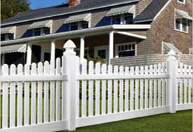
The elegant lines of the Avondale bring out the country charm in any home, whether it's located at the end of a country lane or the middle of town. Replace the maintenance of the classic wooden fence while gaining concave styling and a six-inch bottom rail that removes the temptation from small pets that think they can squeeze under and between the pickets. You'll call it a win-win design for everyone.
- Standard Height Options: 48", 60" or 72"
- Post Spacing Options: 8' center-to-center
- Post Dimensions: 48" High Fence = 5" x 5" x 72" 60" High Fence = 5" x 5" x 96" 72" High Fence = 5" x 5" x 108"
- Standard Post Depth: 48" High Fence = 24" Post Depth 60" High Fence = 36" Post Depth 72" High Fence = 36" Post Depth
- Standard Cap Style: Click here to see post cap options.
- Horizontal Dimensions: Top: 2" x 3 1/2" x 95" Bottom: 2" x 6" x 95"
- Picket Spacing/Picket Dem.: Spacing between pickets: 2" Dimensions: 7/8" Thick x 3" Wide
Ground Clearance: 2"

Brandywine
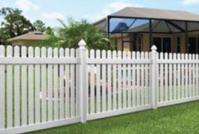
For the nostalgic feel of a traditional picket fence, you can't go wrong with the Brandywine. Its 7/8 x 3-inch pickets are spaced just under two inches apart for the perfect balance of privacy and openness. However, unlike many picket-style fences, the Brandywine features pickets that are flush with the bottom rail for a clean line that's safe for children, pets and lawn equipment.
- Standard Height Options: 36", 42", or 48"
- Post Spacing Options: 8' center to center
- Post Dimensions: 36" HIgh Fence = 5" x 5" x 60" 42" High Fence = 5" x 5" x 66" 48" High Fence = 5" x 5" x 72"
- Standard Post Depth: 36" High Fence = 24" Post Depth 42" High Fence = 24" Post Depth 48" High Fence = 24" Post Depth
- Standard Cap Style: Click here to see post cap options.
- Horizontal Dimensions: 2" Thick x 3 1/2" Wide
- Picket Spacing/Picket Dem.: 1.7" 7/8" Thick x 3" Wide
Ground Clearance: 2"

Brewster
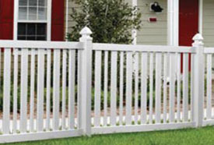
With its clean, crisp top and bottom lines, Brewster is a contemporary pattern that complements any of today's modern home styles. Whether its role is to keep children and pets in the yard, provide a protective barrier around your yard or simply accent the beauty of your home, the Brewster does the job without hiding the aesthetics that lie beyond. Thanks to an alternating combination of 1 1/2 and 3-inch pickets on two-inch spacing, it meets most codes without blocking the view or the breeze.
- Standard Height Options: 36", 42", 48"
- Post Spacing Options: 8' center-to-center
- Post Dimensions: 36" HIgh Fence = 5" x 5" x 60" 42" High Fence = 5" x 5" x 66" 48" HIgh Fence = 5" x 5" x 72"
- Standard Post Depth: 36" High Fence = 24" Post Depth 42" High Fence = 24" Post Depth 48" High Fence = 24" Post Depth
- Standard Cap Style: Click here to see post cap options.
- Horizontal Dimensions: 2" Thick x 3 1/2" Wide Radius corner sections also available
- Picket Spacing/Picket Dem.: 8' Post Spacing: 2" Between Pickets Dimensions: 7/8" Thick x 1 1/2 " Wide & 7/8" Thick x 3" Wide
Ground Clearance: 2"

Georgetown®
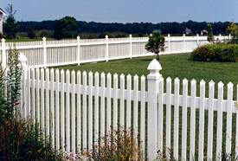
Everybody loves the traditional American picket fence and Country Estate's Georgetown is the most durable and trouble-free picket fence ever. It is meticulously constructed of virgin polyvinyl chloride extrusions that never need painting. They simply shrug off chipping, cracking and rotting problems so common to wood construction. The finest improvement to picket fences came hundreds of years after the fence was originated . . . it's Country Estate's Georgetown.
(Gothic caps optional)
- Standard Height Options: 36", 42", or 48"
- Post Spacing Options: 4' or 6' Center to Center
- Post Dimensions: 36" High Fence = 4" x 4" x 60" 42" High Fence = 4" x 4" x 66" 48" High Fence = 4" x 4" x 72"
- Standard Post Depth: 36" High Fence = 24" Post Depth 42" High Fence = 24" Post Depth 48" High Fence = 24" Post Depth
- Standard Cap Style: Click here to see post cap options.
- Horizontal Dimensions: 2" Thick x 3 1/2" Wide
- Picket Spacing/Picket Dem.: 1 15/32" / 7/8 Thick x 1 1/2" Wide
Ground Clearance: 2"

Nantucket™
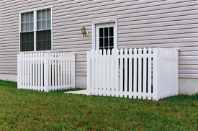
The Nantucket is meticulously constructed of virgin polyvinyl chloride extrusions that never need painting. They simply shrug off chipping, cracking and rotting problems so common to wood construction. The finest improvement to picket fences came hundreds of years after the fence was originated . . . it's Country Estate's Nantucket.
- Standard Height Options: 36", 42", or 48"
- Post Spacing Options: 4' or 6' Center to Center
- Post Dimensions: 36" High Fence = 4" x 4" x 60" 42" High Fence = 4" x 4" x 66" 48" High Fence = 4" x 4" x 72"
- Standard Post Depth: 36" High Fence = 24" Post Depth 42" High Fence = 24" Post Depth 48" High Fence = 24" Post Depth
- Standard Cap Style: Click here to see post cap options.
- Horizontal Dimensions: 2" Thick x 3 1/2" Wide
- Picket Spacing/Picket Dem.: 1 3/4" / 7/8" x 3"
Ground Clearance: 2"

Hampton® Scallop
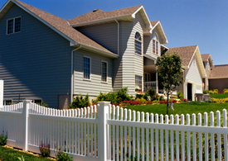
The Hampton Series provides three distinct styles for widely varying American home designs, available with straight, scalloped, or the new step profile. Strong verticals provide plenty of air-flow and semi-privacy at the same time.

(New England caps optional) Check with local building codes for pool enclosure regulations. U.S. Patent No. D378,784
- Standard Height Options: 48", 60", or 72"
- Post Spacing Options: 8' center-to-center
- Post Dimensions: 48" High Fence = 5" x 5" x 72" 60" High Fence = 5" x 5" x 96" 72" High Fence = 5" x 5" x 108"
- Standard Post Depth: 48" High Fence = 24" Post Depth 60" High Fence = 36" Post Depth 72" High Fence = 36" Post Depth
- Standard Cap Style: Click here to see post cap options.
- Horizontal Dimensions: 2" Thick x 3 1/2" Wide (Top) 2" Thick x 6" Wide (Bottom)
- Picket Spacing/Picket Dem.: 1 7/8" / 1 1/2" x 1 1/2"
- Ground Clearance: 2"
Hampton® Step
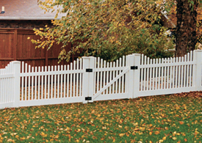

Hampton® Straight
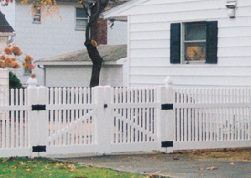

Hannibal®
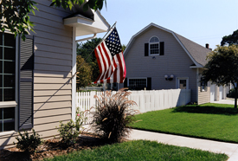
You can almost hear the paddlewheelers churning down the Mississippi on a hot summer day. Country Estate brings the flavor of Mark Twain's time to today's residential settings with the Hannibal traditional board fence . . . without the whitewashing that even Tom Sawyer disliked. The Hannibal is constructed of rugged and durable virgin polyvinyl chloride extrusions that are carefree after installation. Boards won't rot or split nor nails rust with Country Estate fence because PVC construction has replaced them with UV resistance and a timeless feeling like those summers long ago.

(Gothic caps optional)
- Standard Height Options: 36", 42", or 48"
- Post Spacing Options: 4' or 6' center to center
- Post Dimensions: 36" High Fence = 4" x 4" x 60" 42" High Fence = 4" x 4" x 66" 48" High Fence = 4" x 4" x 72"
- Standard Post Depth: 36" High Fence = 24" Post Depth 42" High Fence = 24" Post Depth 48" High Fence = 24" Post Depth
- Standard Cap Style: Click here to see post cap options.
- Horizontal Dimensions: 2" Thick x 3 1/2" Wide
- Picket Spacing/Picket Dem.: 1 3/4" / 7/8" x 3"
Ground Clearance: 2"

Lincolnshire®
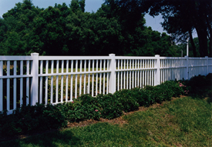
Lincolnshire features diamond shaped verticals for greater strength and reduced open space between pickets. The clean lines and dynamic shadowing appears the same from either side of the fence. This sturdy design looks great with modern home styles.
- Standard Height Options: 48", 60", or 72"
- Post Spacing Options: 8' center-to-center
- Post Dimensions: 48" High Fence = 5" x 5" x 72" 60" High Fence = 5" x 5" x 96" 72" High Fence = 5" x 5" x 108"
- Standard Post Depth: 48" High Fence = 24" Post Depth 60" High Fence = 36" Post Depth 72" High Fence = 36" Post Depth
- Standard Cap Style: Click here to see post cap options.
- Horizontal Dimensions: 3 1/2" Wide x 3 1/2" Thick (Top & Bottom) 2" Wide x 3 1/2" Thick (Middle)
- Picket Spacing/Picket Dem.: 3 1/4" / 1 1/2" x 1 1/2"
Ground Clearance: 2"

Malibu®
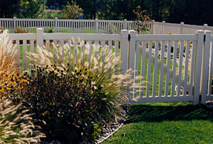
The Malibu from Country Estate is the contemporary design alternative with lifelong durability. Enjoy the beauty of traditional white fence without the traditional maintenance. The clean, smooth lines fit many applications including pool enclosures. (Warning: Check local building codes for pool enclosure regulations.) It is constructed of pure virgin polyvinyl compounds that consistently outperform any and all wood, metal or imitation polyvinyl fence products.
(Gothic caps optional)
- Standard Height Options: 36", 42", or 48"
- Post Spacing Options: 4' or 6' center-to-center
- Post Dimensions: 36" High Fence = 4" x 4" x 60" 42" High Fence = 4" x 4" x 66" 48" High Fence = 4" x 4" x 72"
- Standard Post Depth: 36" High Fence = 24" Post Depth 42" High Fence = 24" Post Depth 48" High Fence = 24" Post Depth
- Standard Cap Style: Click here to see post cap options.
- Horizontal Dimensions: 2" Thick x 3 1/2" Wide
- Picket Spacing/Picket Dem.: 4' Post Spacing 1 13/16" Between Pickets 6' Post Spacing 1 7/8" Between Pickets Dimensions: 1" Thick x 2" Wide
Ground Clearance: 2"

Springfield®
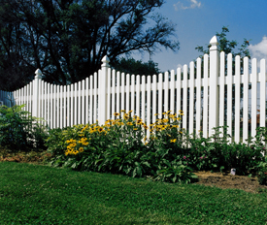
The Springfield creates a nostalgic ambience of elegance, privacy . . . and turn-of-the century beauty as richly American as popcorn, lemonade, and Fourth of July firecrackers. But, the beauty doesn't end there . . . like all Country Estate PVC fence products, you'll never spend a single hour painting it. It is impervious to weather and it won't rot, peel, or blister. Just enjoy, year after year after year.
Country Estate Springfield adapts well to sloping terrain: note "steps"on bottom of fence sections. Note: "Standard" Springfield gates are scalloped up, unless specified.(Gothic caps optional)
- Standard Height Options: 48", 60", or 72"
- Post Spacing Options: 8' center-to-center
- Post Dimensions: 48" High Fence = 5" x 5" x 72" 60" High Fence = 5" x 5" x 96" 72" High Fence = 5" x 5" x 108"
- Standard Post Depth: 48" High Fence = 24" Post Depth 60" High Fence = 36" Post Depth 72" High Fence = 36" Post Depth
- Standard Cap Style: Click here to see post cap options.
- Horizontal Dimensions: 1 1/2" x 5 1/2"
- Picket Spacing/Picket Dem.: 2" / 7/8" x 3"
Ground Clearance: 2"

Semi Privacy

Lakeview
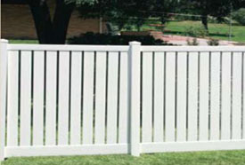
With its 5 1/2-inch vertical pickets, the Lakeview offers semi-privacy combined with nominal air flow for that perfect blend of openness and seclusion, particularly in areas that are prone to high winds. The approximate one-inch spacing between pickets all but block the view looking in, especially when viewed at an angle.
- Standard Height Options: 48", 60" or 72"
- Post Spacing Options: 8' center-to-center
- Post Dimensions: 48" High Fence = 5" x 5" x 84" 60" High Fence = 5" x 5" x 96" 72" High Fence = 5" x 5" 108"
- Standard Post Depth: 48" High Fence = 36" Post Depth 60" High Fence = 36" Post Depth 72" High Fence = 36" Post Depth (Local conditions may require additional depth.)
- Standard Cap Style: Click here to see post cap options.
- Horizontal Dimensions: 2" Thick x 3 1/2" Wide (Top) 2" Thick x 7" Wide (Bottom)
- Picket Spacing/Picket Dem.: Approx. 1" Between Pickets 1 1/2 " Thick x 5 1/2" Wide
Ground Clearance: 2"

Dawson™
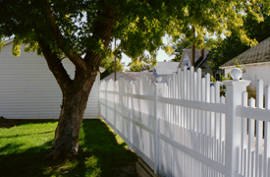
The Dawson is designed for elegance. It is at home with many modern or classic American homes. Traditional Country Estate construction includes sturdy 5" x 5" posts, reinforced horizontals and exquisite cap design. Dawson provides semi-privacy with a hint of the landscape behind it. See your Country Estate authorized independent dealer for all of the details.

(Gothic caps and post enders optional)
- Standard Height Options: 48", 60", 72"
- Post Spacing Options: 8' center-to-center
- Post Dimensions: 48" High Fence = 5" x 5" x 72" 60" High Fence = 5" x 5" x 96" 72" High Fence = 5" x 5" x 108"
- Standard Post Depth: 48" High Fence = 24" Post Depth 60" High Fence = 36" Post Depth 72" High Fence = 36" Post Depth
- Standard Cap Style: Click here to see post cap options.
- Horizontal Dimensions: 2" Thick x 3.5" Wide (Top) 2" Thick x 3.5" Wide (Middle) 2" Thick x 6" Wide (Bottom)
- Picket Spacing/Picket Dem.: 1 1/2" Thick x 1 1/2" Wide
Ground Clearance: 2"

Kensington®
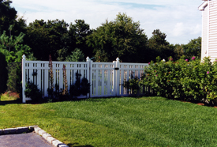
There was a time when fences were considered a restriction . . . a wall of sorts. Country Estate's many privacy and residential fence designs are changing that perception. Kensington's trim efficiency will add beauty and value to your property while allowing air flow. Your neighbors will recognize it as a strikingly beautiful addition to the neighborhood and it will never become an eye-sore begging for paint. The boards won't peel or blister, the nails won't rust, and the posts won't rot off. Country Estate Fence replaces those problems with ultra-violet resisters and impact modifiers that assure strength and beauty.
(Gothic caps optional)
- Standard Height Options: 48", 60", 72", 84", 96"
- Post Spacing Options: 6' or 8' center-to-center
- Post Dimensions: 48" High Fence = 5" x 5" x 72" 60" High Fence = 5" x 5" x 96" 72" High Fence = 5" x 5" x 108" 84" High Fence = 5" x 5" x 120" 96" High Fence = 5" x 5" x 144"
- Standard Post Depth: 48" High Fence = 24" Post Depth 60" High Fence = 36" Post Depth 72" High Fence = 36" Post Depth 84" High Fence = 36" Post Depth 96" High Fence = 48" Post Depth
- Standard Cap Style: Click here to see post cap options.
- Horizontal Dimensions: 2" Thick x 3 1/2" Wide
- Picket Spacing/Picket Dem.: 6' Post Spacing 1-7/32" Between Pickets 8' Post Spacing 1 3/8" Between Pickets Dimensions: 1" Thick x 6" Wide and 1" Thick x 2" Wide
Ground Clearance: 2"

Rochester™
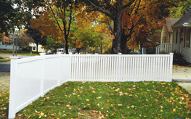
Rochester provides semi-privacy with plenty of free airflow. The clean design makes it ideal for many home styles. You'll like the neighbor friendly style because it looks identical from either side.
- Standard Height Options: 48", 60", 72"
- Post Spacing Options: 8' center-to-center
- Post Dimensions: 48" High Fence = 5" x 5" x 72" 60" High Fence = 5" x 5" x 96" 72" High Fence = 5" x 5" x 108"
- Standard Post Depth: 48" High Fence = 24" Depth 60" High Fence = 36" Depth 72" High Fence = 36" Depth
- Standard Cap Style: Click here to see post cap options.
- Horizontal Dimensions: 2" x 3 1/2" (Top, Mid & Bottom Rails)
- Picket Spacing/Picket Dem.: 7/8" x 3"
Ground Clearance: 2"

Dura-Lattice™
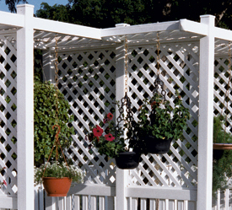
The Europeans use lattice throughout their homes, yards and flower gardens because it provides a beautiful setting for flowers and greenery. Durable PVC lattice by Country Estate is one of the most creative tools you can find today. These traditional lattice panels, constructed of scientifically formulated 100% virgin PVC compounds, never need painting. Maintenance? It's reduced to an absolute minimum -- no flaking, blistering or rotting, and that's important since nearly all lattice touches the soil or plants at some point. We've combined the beauty of lattice with the impressive durability of PVC for a product with nearly unlimited design capabilities. Bring that Mediterranean feeling to your own yard today. . . with Country Estate Dura-Lattice.

SIZES AVAILABLE
4' x 8' Panels
1/4" x 1 1/2" strips placed at 45 degree angle
2" openings

Privacy Style

Caribbean®
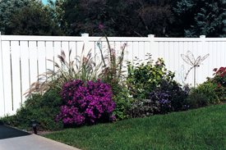
The clean lines of Caribbean style fence are like a welcome sea breeze. Carefully spaced verticals let fresh air flow through without sacrificing the privacy you desire. Concerned about design? You'll find the sleek Caribbean style is complimentary to many of today's modern home styles. While your neighbors are scraping and painting their wood fence, you can lean back in your lawn chair and silently congratulate yourself for choosing Country Estate Fence, free from traditional maintenance.
- Standard Height Options: 48", 60", 72", 84", 96"
- Post Spacing Options: 6' or 8' center-to-center
- Post Dimensions: 48" High Fence = 5" x 5" x 72" 60" High Fence = 5" x 5" x 96" 72" High Fence = 5" x 5" x 108" 84" High Fence = 5" x 5" x 120" 96" High Fence = 5" x 5" x 144"
- Standard Post Depth: 48" High Fence = 24" Post Depth 60" High Fence = 36" Post Depth 72" High Fence = 36" Post Depth 84" High Fence = 36" Post Depth 96" High Fence = 48" Post Depth
- Standard Cap Style: Click here to see post cap options.
- Horizontal Dimensions: 2" Thick x 3 1/2" Wide
- Picket Spacing/Picket Dem.: 6' Post Spacing 5/8" Between Pickets 8' Post Spacing 15/16" Between Pickets 1" Thick x 6" Wide
Ground Clearance: 2"

Denver®
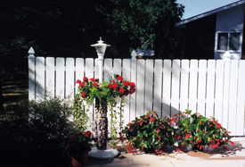
Now the traditional "stockade" fence is available from Country Estate. This unique style provides privacy and air-flow. It works well as a screen for unsightly areas, and regardless of its age, The Denver style fence never needs painting. Of course, that also means it never needs scraping, and the finish will never peel or blister like painted wood. You can enjoy Denver with wide verticals or integrate a narrower Hannibal vertical between each Denver panel (we call it Hanver). The Hannibal and Denver caps are designed with identical bevels, so they look great together.
(Gothic caps and post enders optional)
- Standard Height Options: 48", 60", or 72"
- Post Spacing Options: 4' or 6' center-to-center
- Post Dimensions: 48" High Fence = 5" x 5" x 84" 60" High Fence = 5" x 5" x 96" 72" High Fence = 5" x 5" x 108"
- Standard Post Depth: 48" High Fence = 36" Post Depth 60" High Fence = 36" Post Depth 72" High Fence = 36" Post Depth
- Standard Cap Style: Click here to see post cap options.
- Horizontal Dimensions: 2" Thick x 3 1/2" Wide
- Picket Spacing/Picket Dem.: 4' Post Spacing 1/8" Between Pickets 6' Post Spacing 5/8" Between Pickets Dimensions: 1" Thick x 6" Wide
Ground Clearance: 2"

Hanver®
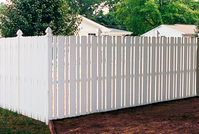
Now the traditional "stockade" fence is available from Country Estate. This unique style provides privacy and air-flow. It works well as a screen for unsightly areas, and regardless of its age, The Denver style fence never needs painting. Of course, that also means it never needs scraping, and the finish will never peel or blister like painted wood. You can enjoy Denver with wide verticals or integrate a narrower Hannibal vertical between each Denver panel (we call it Hanver). The Hannibal and Denver caps are designed with identical bevels, so they look great together.
(Gothic caps optional)
- Standard Height Options: 48", 60", or 72"
- Post Spacing Options: 4' or 6' center-to-center
- Post Dimensions: 48" High Fence = 5" x 5" x 84" 60" High Fence = 5" x 5" x 96" 72" High Fence = 5" x 5" x 108"
- Standard Post Depth: 48" High Fence = 36" Post Depth 60" High Fence = 36" Post Depth 72" High Fence = 36" Post Depth
- Standard Cap Style: Click here to see post cap options.
- Horizontal Dimensions: 2" Thick x 3 1/2" Wide
- Picket Spacing/Picket Dem.: 4' Post Spacing 25/32" Between Pickets 6' Post Spacing 1" Between Pickets Dimensions: 1" Thick x 6" Wide & 7/8" Thick x 3" Wide
Ground Clearance: 2"

Lakeland®
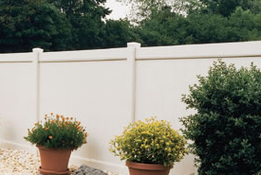
The Lakeland provides a solid privacy wall that features tongue and groove verticals for greater fence strength. Some Country Estate customers prefer Lakeland as pictured here . . . but others add a decorative eye-level layer of lattice. Lakeland has proven to be a solid choice among homeowners who want full privacy for their yard.
- Standard Height Options: 48", 60", 72", 84", 96"
- Post Spacing Options: 8' center-to-center
- Post Dimensions: 48" High Fence = 5" x 5" x 84" 60" High Fence = 5" x 5" x 96" 72" High Fence = 5" x 5" x 108" 84" High Fence = 5" x 5" x 120" 96" High Fence = 5" x 5" x 144"
- Standard Post Depth: 48" High Fence = 36" Depth 60" High Fence = 36" Depth 72" High Fence = 36" Depth 84" High Fence = 48" Depth 96" High Fence = 48" Depth
- Standard Cap Style: Click here to see post cap options.
- Horizontal Dimensions: 1 1/2" Thick x 5 1/2" Wide (Top/Each Side- Convex & Concave) 2" Thick x 7" Wide (Top-Mid) 2" Thick x 7" Wide (Bottom)
- Picket Spacing/Picket Dem.: 7/8" Thick x 7" Wide
- Ground Clearance: 2"
Lakeland® (concave)
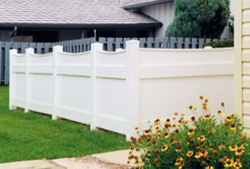

Lakeland® (convex)
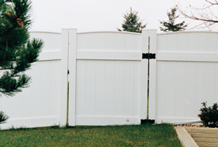

Lakeland® with Spider Board Option
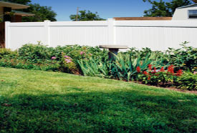
Learn more about the new Country Estate Spider Board.

Hollingsworth™
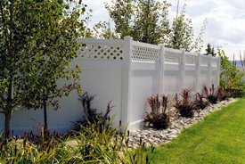
The Hollingsworth offers the same solid privacy wall as the Lakeland, but adds a decorative eye-level layer of lattice. It has proven to be a solid choice among homeowners who want full privacy for their yard.

The Hollingworth is also available with the Spider Board option.
- Standard Height Options: 48", 60", 72", 84", 96"
- Post Spacing Options: 8' center-to-center
- Post Dimensions: 48" High Fence = 5" x 5" x 84" 60" High Fence = 5" x 5" x 96" 72" High Fence = 5" x 5" x 108" 84" High Fence = 5" x 5" x 120" 96" High Fence = 5" x 5" x 144"
- Standard Post Depth: 48" High Fence = 36" Depth 60" High Fence = 36" Depth 72" High Fence = 36" Depth 84" High Fence = 48" Depth 96" High Fence = 48" Depth
- Standard Cap Style: Click here to see post cap options.
- Horizontal Dimensions: 2" x 3 1/2" (Top Rail) 2" Thick x 7" Wide (Top-Mid) 2" Thick x 7" Wide (Bottom)
- Picket Spacing/Picket Dem.: 7/8" Thick x 7" Wide
Ground Clearance: 2"

Montauk™
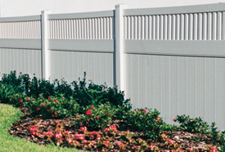
The Country Estate Montauk Series provides the privacy you desire beyond a simple wall. You can control the appearance by selecting one of our family of styles which has been designed by our Country Estate dealers to accommodate various home styles across America.

The Montauk styles are also available with the Spider Board option.
- Standard Height Options: 48", 60", 72", 84", 96"
- Post Spacing Options: 8' center-to-center (96" High - 75" center-to-center)
- Post Dimensions: 48" High Fence = 5" x 5" x 84" 60" High Fence = 5" x 5" x 96" 72" High Fence = 5" x 5" x 108" 84" High Fence = 5" x 5" x 120" 96" High Fence = 5" x 5" x 144"
- Standard Post Depth: 48" High Fence = 36" Depth 60" High Fence = 36" Depth 72" High Fence = 36" Depth 84" High Fence = 36" Depth 96" High Fence = 48" Depth
- Standard Cap Style: Click here to see post cap options.
- Horizontal Dimensions: 2" Thick x 7" Wide (Bottom) 2" Thick x 7" Wide (Middle) 2" Thick x 3 1/2" Wide (Top)
- Picket Spacing/Picket Dem.: 7/8" x 7" (Bottom) 1 1/2" x 1 1/2" (Top)
- Ground Clearance: 2"
Montauk™ (scallop)
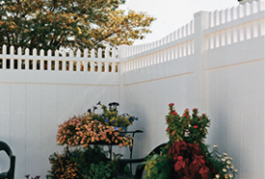

Montauk™ (straight)
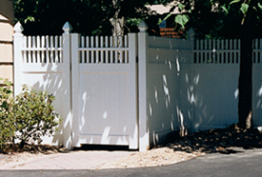

Montauk™ (step)
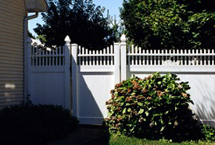

Melbourne®
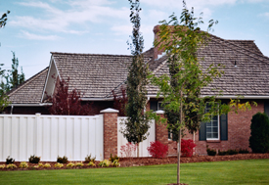
Melbourne provides complete privacy while permitting air to pass between the verticals. Great for surrounding patios or swimming pools. Notice the interesting shadow effect created by the offset verticals.
- Standard Height Options: 48", 60", or 72"
- Post Spacing Options: 8' center-to-center
- Post Dimensions: 48" High Fence = 5" x 5" x 72" 60" High Fence = 5" x 5" x 96" 72" High Fence = 5" x 5" x 108"
- Standard Post Depth: 48" High Fence = 24" Post Depth 60" High Fence = 36" Post Depth 72" High Fence = 36" Post Depth
- Standard Cap Style: Click here to see post cap options.
- Horizontal Dimensions: 3 1/2" x 3 1/2"
- Picket Spacing/Picket Dem.: 5 3/8" / 1" x 6"
- Ground Clearance: 2"
Melbourne® with Lattice
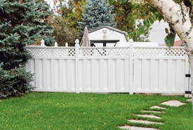

Windsor®
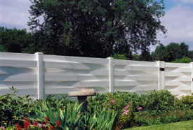
Gain the total privacy you desire in a modern ranch-style fence design. We call it Windsor--many refer to it as "basketweave". Regardless what you call it, this product is free from traditional maintenance. Country Estate Fence features PVC construction entirely with virgin compounds, impervious to moisture and freezing temperatures, and it won't peel, blister or rot. Forget painting, it's never needed with Country Estate Fence. When you select our product, you've eliminated the traditional maintenance found with wood, metal or imitation polyvinyl fence.
- Standard Height Options: 48", 60", or 72"
- Post Spacing Options: 8' center-to-center
- Post Dimensions: 48" High Fence = 5" x 5" x 84" 60" High Fence = 5" x 5" x 96" 72" High Fence = 5" x 5" x 108" (Heavy Wall)
- Standard Post Depth: 48" High Fence = 36" Post Depth 60" High Fence = 36" Post Depth 72" High Fence = 36" Post Depth
- Standard Cap Style: Click here to see post cap options.
- Horizontal Dimensions: 1" x 6"
Ground Clearance: 2"

Neighbor Friendly

Atlantic™
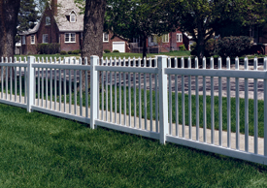
Relive a walk on the beachfront every time you step out the front door with Atlantic, as each look at the nostalgic design evokes memories of picnics and homemade ice cream. Your neighbors will feel the same, too, thanks to its Neighbor-Friendly design, which looks the same from either side.
- Standard Height Options: 36", 42" and 48"
- Post Spacing Options: 6' center-to-center
- Post Dimensions: 36" = 4" x 4" x 60" 42" = 4" x 4" x 66" 48" = 4" x 4" x 72"
- Standard Post Depth: 36" High Fence= 24" 42" High Fence= 24" 48" High Fence= 24"
- Standard Cap Style: Click here to see post cap options.
- Horizontal Dimensions: 2" Thick x 3 1/2" Wide x 71" Long
- Picket Spacing/Picket Dem.: 7/8" Thick x 1 1/2" Wide 3 1/2" spacing
Ground Clearance: 2"

Cape Cod™
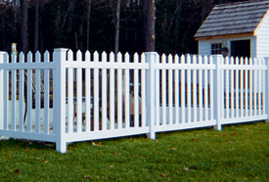
Enjoy the nostalgic look of Cape Cod and still meet the 50% percent open specification required by some building codes. This classic adds a rich look to any contemporary home without the headaches often associated with a picket fence... like fading, peeling and cracking.
- Standard Height Options: 36" , 42" and 48"
- Post Spacing Options: 72" center-to-center
- Post Dimensions: 36" = 4" x 4" x 60" 42" = 4" x 4" x 66" 48" = 4" x 4" x 72"
- Standard Post Depth: 36" High Fence= 24" 42" High Fence= 24" 48" High Fence= 24"
- Standard Cap Style: Click here to see post cap options.
- Horizontal Dimensions: 2" Thick x 3 1/2" Wide x 71" Long
- Picket Spacing/Picket Dem.: 7/8" Thick x 3" Wide (spade top picket) 3 1/2" spacing
Ground Clearance: 2"

Missouri™
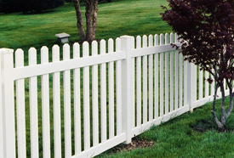
Tom Sawyer would have loved the clean look of the picket-style Missouri fence, no matter which side faced his beloved Mississippi River. Best of all, he would have never had the chore of painting it every few years, or had to con his friends into helping him.
- Standard Height Options: 36" , 42" and 48"
- Post Spacing Options: 6' center-to-center
- Post Dimensions: 36" = 4" x 4" x 60" 42" = 4" x 4" x 66" 48" = 4" x 4" x 72"
- Standard Post Depth: 36" High Fence= 24" 42" High Fence= 24" 48" High Fence= 24"
- Standard Cap Style: Click here to see post cap options.
- Horizontal Dimensions: 2" Thick x 3 1/2" Wide x 71" Long
- Picket Spacing/Picket Dem.: 7/8" Thick x 3" Wide 3 1/2" spacing
Ground Clearance: 2"

Pacific™
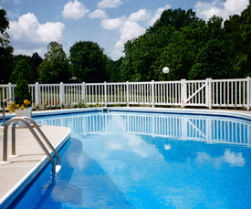
Available in three heights, the Pacific provides a secure boundary for pets and children, yet provides free air movement and a clean look that complements any yard. Its simple, smooth-line design can be further personalized with your choice of cap designs to make it your own.
Check with local building codes for pool enclosure regulations.
- Standard Height Options: 36" , 42" and 48"
- Post Spacing Options: 6' center-to-center
- Post Dimensions: 36" = 4" x 4" x 60" 42" = 4" x 4" x 66" 48" = 4" x 4" x 72"
- Standard Post Depth: 36" High Fence= 24" 42" High Fence= 24" 48" High Fence= 24"
- Standard Cap Style: Click here to see post cap options.
- Horizontal Dimensions: 2" Thick x 3 1/2" Wide x 71" Long
- Picket Spacing/Picket Dem.: 7/8" Thick x 1 1/2" Wide (on diamond shape) 3 1/2" spacing
Ground Clearance: 2"

Pacific Diamond™
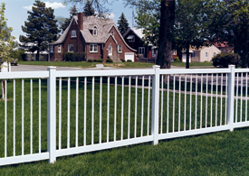
Available in three heights, the Pacific provides a secure boundary for pets and children, yet provides free air movement and a clean look that complements any yard. Its simple, smooth-line design can be further personalized with your choice of cap designs to make it your own.
- Standard Height Options: 36" , 42" and 48"
- Post Spacing Options: 6' center-to-center
- Post Dimensions: 36" = 4" x 4" x 60" 42" = 4" x 4" x 66" 48" = 4" x 4" x 72"
- Standard Post Depth: 36" High Fence= 22" 42" High Fence= 22" 48" High Fence= 22"
- Standard Cap Style: Click here to see post cap options.
- Horizontal Dimensions: 2" Thick x 3 1/2" Wide x 71" Long
- Picket Spacing/Picket Dem.: 1" Thick x 1" Wide (on diamond shape) 3 11/16" spacing
Ground Clearance: 2"

Potomac™
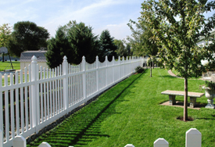
With its sturdy, evenly spaced pickets, the Potomac provides a distinctive style that complements a variety of home designs. Yet, this economical option still offers all the trouble-free features of virgin polyvinyl that make it free from traditional maintenance.
- Standard Height Options: 48", 60" and 72"
- Post Spacing Options: 6' center-to-center
- Post Dimensions: 48" = 5" x 5" x 72" 60" = 5" x 5" x 96" 72" = 5" x 5" x 108"
- Standard Post Depth: 48" High Fence = 24" 60" High Fence = 36" 72" High Fence = 36"
- Standard Cap Style: Click here to see post cap options.
- Horizontal Dimensions: 2" Thick x 3 1/2" Wide x 71" Long (top) 2" Thick x 6" Wide x 71" Long (bottom)
- Picket Spacing/Picket Dem.: 7/8" Thick x 3" Wide 3 11/32" spacing
Ground Clearance: 2"

Sacramento™
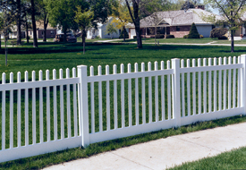
With its 1 1/2-inch square pickets, the Sacramento is the perfect compromise between a traditional picket fence and a contemporary Pacific style. As a result, it's looks equally at home beside a concrete driveway or a brick sidewalk.
- Standard Height Options: 48", 60" and 72"
- Post Spacing Options: 6' center-to-center
- Post Dimensions: 48" = 5" x 5" x 72" 60" = 5" x 5" x 96" 72" = 5" x 5" x 108"
- Standard Post Depth: 48" High Fence = 24" 60" High Fence = 36" 72" High Fence = 36"
- Standard Cap Style: Click here to see post cap options.
- Horizontal Dimensions: 2" Thick x 3 1/2" Wide x 71" Long (top) 2" Thick x 6" Wide x 71" Long (bottom)
- Picket Spacing/Picket Dem.: 1 1/2" Thick x 1 1/2" Wide 3 3/4" spacing
Ground Clearance: 2"

Country Estate Rail Fence

2 Rail Fence
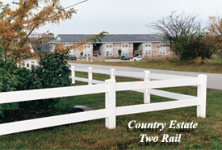
Material Specifications

Rigid PVC Hompolymer compound. Modified for cold weather impact retention.

Cell Classification- ASTM D-4216 1-43332-32-0000
Cell Classification- ASTM D-1784 14344B

Typical values:
ASTM D256 Izod Impact (Ft. lbs./inch notch)
23 degree C-5.0 0 degree C-2.0
ASTM D638 Tensile Strength 6,500 psi
ASTM D638 Tensile Modulus 545,000 psi*
ASTM D648 Deflection Temp. 71 degree C
ASTM D4226 Drop Dart Procedure A 2.51 (in.-lb/mil)
ASTM D4226 Drop Dart Procedure B 4.50 (in.-lb/mil)
ASTM D695 Compressive (Yield) Strength 8,780 psi
ASTM D696 Thermal Expansion 4.4 x 10-5 in./in./degree F
ASTM D732 Shear Strength 6,780 psi
ASTM D790 Flexural Strength 11,400 psi
* Tensile Modulus should be used for design purposes with caution. Values
listed are representative for short term loading (such as livestock pushing
on fence). The long term creep characteristics under continuous loading
are unknown.

Standard Specifications

For Rail Fence (Conforms to ASTM F964)
Fence Rails
TxW: 1 1/2 x 5 1/2"; 2" x 6", 2 7/8"round
Length: 16'

Fence Posts
TxW: 5" x 5"; 5" O.D. round
Length: 6',7',8'

Click here to see post cap options.
TxW: 5" x 5"; 5" O.D. round
Fence Post Bracket
TxW: 1 1/2" x 5 1/2"; 2" x 6"

These standard measurements apply to both 1-1/2" x 5-1/2" rails and 2" x 6" rails.

*On all Country Estate® rail fencing, the top rail is mounted 2" from the top of the post.

*On two-rail and three-rail fencing, there is 11 inches between rails.

*On four-rail fencing, there is 9 inches between rails.
Radius corner sections also available

3 Rail Fence
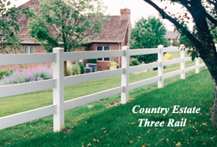
Material Specifications

Rigid PVC Hompolymer compound. Modified for cold weather impact retention.

Cell Classification- ASTM D-4216 1-43332-32-0000
Cell Classification- ASTM D-1784 14344B

Typical values:
ASTM D256 Izod Impact (Ft. lbs./inch notch)
23 degree C-5.0 0 degree C-2.0
ASTM D638 Tensile Strength 6,500 psi
ASTM D638 Tensile Modulus 545,000 psi*
ASTM D648 Deflection Temp. 71 degree C
ASTM D4226 Drop Dart Procedure A 2.51 (in.-lb/mil)
ASTM D4226 Drop Dart Procedure B 4.50 (in.-lb/mil)
ASTM D695 Compressive (Yield) Strength 8,780 psi
ASTM D696 Thermal Expansion 4.4 x 10-5 in./in./degree F
ASTM D732 Shear Strength 6,780 psi
ASTM D790 Flexural Strength 11,400 psi
* Tensile Modulus should be used for design purposes with caution. Values
listed are representative for short term loading (such as livestock pushing
on fence). The long term creep characteristics under continuous loading
are unknown.

Standard Specifications

For Rail Fence (Conforms to ASTM F964)
Fence Rails
TxW: 1 1/2 x 5 1/2"; 2" x 6", 2 7/8"round
Length: 16'

Fence Posts
TxW: 5" x 5"; 5" O.D. round
Length: 6',7',8'

Click here to see post cap options.
TxW: 5" x 5"; 5" O.D. round
Fence Post Bracket
TxW: 1 1/2" x 5 1/2"; 2" x 6"

These standard measurements apply to both 1-1/2" x 5-1/2" rails and 2" x 6" rails.

*On all Country Estate® rail fencing, the top rail is mounted 2" from the top of the post.

*On two-rail and three-rail fencing, there is 11 inches between rails.

*On four-rail fencing, there is 9 inches between rails.
Radius corner sections also available

Equine Fencing
Material Specifications
Rigid PVC Homopolymer compound. Modified for cold weather impact retention.

Cell Classification - ASTM D-4216 1-43332-32-0000
Cell Classification - ASTM D-1784 14344B

Typical values:
ASTM D256 Izod Impact (Ft. lbs./inch notch)
23*C-5.0 0*C-2.0

ASTM D638 Tensile Strength 6,500 psi
ASTM D638 Tensile Modulus 545,000 psi*
ASTM D648 Deflection Temp. 71*C
ASTM D4226 Drop Dart Procedure A 2.51 (in.-lb/mil)
ASTM D4226 Drop Dart Procedure B 4.50 (in.-lb/mil)
ASTM D695 Compressive (Yield) Strength 8,780 psi
ASTM D696 Thermal Expansion 4.4 x 10-5 in./in./*F
ASTM D732 Shear Strength 6,780 psi
ASTM D790 Flexural Strength 11,400 psi
* Tensile Modulus should be used for design purposes with caution. Values listed are representative for short term loading (such as livestock pushing on fence). The long term creep characteristics under continuous loading are unknown.
Standard Specifications
For Rail Fence (Conforms to ASTM F964)

Country Estate's Contribution to the Equine Industry
During the late 1970's, Country Estate Fencing was introduced to large Standardbred Horse Farms in upstate New York and New England. Professional horse handlers and the owners of expensive breeding stock quickly realized that Country Estate's polyvinyl fencing not only reduced fencing costs but also reduced injuries caused by fencing! And this outstanding product was also so beautiful that it enhanced the value of their properties. Once the equine industry became convinced that PVC fencing withstands New England's harsh winters as well as the searing heat of south Texas, Country Estate Fencing for horses became the fence of choice all across the United States.

Today, Country Estate Fence remains the leader in cost-effective fence that is free from all traditional fence maintenance. Exhaustive laboratory tests and field experience on horse farms throughout the Untied States fully support all claims of economy and safety. Country Estate Fence polyvinyl components are constructed of scientifically formulated 100% virgin PVC compounds consistently out performing any and all wood, metal or imitation polyvinyl fence products.

Since the introduction of Country Estate Fence, equine professionals have applauded the greater protection polyvinyl fence provides their animals. The day Country Estate Fence is installed, all traditional fence maintenance halts.
Our Customers Say it Best
" Four years ago I purchased horse property, built my dream horse barn, and was ready to put up state-of-the-art PVC fencing. The price of the fence was very affordable from a local fence manufacturer. I spent my hard earned money and my efforts into installing a fence that I did not research fully. I saw their twenty year warranty and thought, "How can I go wrong?"

The first really cold winter day after the fence was installed I learned of my mistake. My mare kicked a fence rail and it shattered into little pieces. I called for warranty replacement only to learn that the company was no longer in business! I called the Better Business Bureau and found that there were complaints against the fence manufacturer other than mine.

Later that year I put up an additional PVC corral from another fence manufacturer after fully researching references and checking with the Better Business Bureau. My new PVC fence is still wonderful after three years. My horses have slid into it, sat on it, and tangled into it by rolling without causing any damage to the fence or horses. It did cost more than the inferior fence I originally purchased, but I got a great product this time."
Mary Melton - West Chicago, IL

Gates
A fence is only as good as its gates...find out why ours are the best!

We offer matching gates for all of our fence styles. Country Estate gates include diagonal bracing and patented gate sockets for a long service life. Your Country Estate Authorized Independent Dealer will custom-build your gates to perfectly match your property. Single walk gates, double drive gates...design your fence to work for you!

Railing
Railing

Country Estate Railings provide a beautiful finishing touch to any property and are free from traditional maintenance. The wide selection of styles provides a beautiful complement for virtually any type of architecture.

All Country Estate Railings (except teardrop baluster) meet or exceed ICC specifications listed in AC-174 and have been independently verified by Architectural Testing Incorporated. You can view the Nebraska Plastics, Inc. Code Compliance Research Report at www.archtest.com.

Country Estate Railings are designed with aesthetics and safety in mind. When properly installed, Country Estate Railings are a beautiful and secure addition to your construction project.

Country Estate Railings are made with 100% virgin polyvinyl and reinforced with a system of aluminum and wood for lasting superior structural integrity.

Decking

* Always cool to the touch and kind to bare feet. Surface is embossed for a non-slick surface.

* Much easier to wash than wooden or concrete surfaces.

* Available in white, gray, almond and adobe.

* Country Estate Decking is made from 100% virgin PVC.

* Never discolors from pressure washing or constant exposure to water.

* Forget slivers, rotting deck or squeaks.

* No nail heads to snag- snow scoops off easily.

* No more waterproofing with sealants or chemicals again - a safer play surface for children.

Colors & Options
So many fences...So many choices...

Country Estate Vinyl Products are available in white, almond, gray and adobe. We have a variety of optional cap styles to choose from as well.

If you are interested in a Lakeland privacy fence or a rail fence and prefer a more wood-grained look, ask your local Country Estate Authorized Independent Dealer to talk to you about streaking and embossing options for these fence styles.

“Streaking” is a new process in which a darker colored pigment is streaked through either our almond or gray material to give a variegated, wood grain appearance. The surface of the material is smooth (although it is suitable for our new embossing process if you also want a simulated wood-textured surface) and it is the same quality material that we use in our solid-colored products. Streaking is available in almond or gray.

Our embossed products are our regular, high quality Country Estate profiles, but they are embossed with a wood grain pattern. We think these embossed products will suit the tastes of customers who prefer a fence with a more wood-like appearance and a less glossy finish than our standard vinyl profiles. Embossing is also available in our Country Estate Decking.

No Lead Added
PVC You Can Trust

There is currently no federal law in the United States that prohibits producing or selling vinyl products which contain lead. It is up to the manufacturers of vinyl products to police themselves and follow ethical business practices to keep lead out of their products.

Nebraska Plastics, the manufacturer of Country Estate vinyl fence, deck and railing, feels that consumers should not have to worry about harmful lead hidden in PVC products and is proud to be able to state that they never have and never will use lead as a stabilizer in their vinyl products.

Warranty Information
We are convinced that Country Estate's non-prorated 50-year Warranty is the industry's strongest warranty.

Testimonials
Our Customers Say it Best!

We are very happy with your product & extremely impressed with the dealer/installer-they do beautiful work. We purchased your Country Estate 3 Rail fence & posts (approximately 2,000 feet) ten years ago and it still looks beautiful and is very durable. We fenced our horse pasture with it, holding four horses in it, with no problems at all.
T.W.- Morrison, IL

I am very happy with the fence! I have had numerous compliments on the beauty of it. Friends and strangers have stopped to get a good look. Some come to the house to ask where and who put it in. Our Country Estate Dealer was very helpful in helping me decide location, length, end pieces, etc.
M.E.C. - Charlton City, MA

Our dealer was prompt to take care of our needs and requests. We are very pleased with the project. M.R.J.-Omaha, NE

With the expertise of our Country Estate dealer, my back yard looks like a million bucks!
C.C. - Rosedale, NY

I have had three wood fences with 20-year guarantees that have rotted out. This one will last and always look new.
C.W. - Yorba Linda, CA

We have received so many great comments about the Hampton fence. It was almost overwhelming. It truly changed the look of our house.
G.P. - Carmel, IN

I was very impressed with the quality of work performed by the installer. He was courteous, neat and a very skilled craftsman.
E.G. - Oswego, IL

Both my wife and I are very happy with our fence. Some of our friends liked it also and have contracted our Country Estate dealer to install fences around their pools.
R.G. - Bloomsburg, PA

Wonderful products! These were great people to work with. We highly recommend our Country Estate dealer to anyone wanting a fence from a fair, honest and courteous businessman. He went out of his way to meet our needs.
E.W. - Spokane, WA

We are very happy with the quality of the product and the professional manner in which it was installed.
S.H. - Green Bay, WI

We have the best fence at Lake Barnadette Golf Course. All our neighbors want to do theirs. We have given or passed the name of the company who did our fence and hoped for the best. We selected 3 companies who could have done the job. We liked the design and the price was right from our Country Estate dealer. They did a great job! Thank you.
M.P. - Zephyrhills, FL

Staff and Service were beyond anything we expected. It's a treat when people really care and show it. Thanks.
T.S.T. - Calgary, Alberta
The manager took the time to drive 30 miles to our home and visit with me about the fence type I wanted, the way it would be put up and how it would blend in with our home, at no cost or high pressure sales pitch. I also talked to other dealers of fencing and they would not take the time to come to our home and see what I wanted to do. I would highly recommend Country Estate dealers to anyone! Their workers are neat, clean and take an interest in the job they do.
B.P. - Hutchinson, KS
Gary Goscha
Olathe, KS
After twenty years of raising Paso Fino horses, I've purchased and maintained almost every type of fence at one time or another. Seven years ago I purchased Country Estate PVC fencing for the first time. I bought PVC fence for the durability and the claim to be a maintenance-free fence. It seemed expensive at the time compared to other fencing, but when I total the installation, cost of material and maintenance over a five year period, I'm money ahead. After seven years, my PVC fence still looks the same as the day it was installed. The sun hasn't bleached or yellowed it and I have never painted the fence. I studied different brands of PVC fence for a year. The thickness of the PVC was the main reason I decided to purchase Country EstateFence. I wanted a true 100% virgin polyvinyl fence rather than an inferior regrind or co-extruded PVC product. I wanted the best PVC fence product available and the 100% virgin polyvinyl fence was the only kind I had full faith in. Once I saw the first section of Country Estate Fence going up, I knew that this was a great product. I've installed Country Estate Fence every year since and I am very satisfied with the results. The confinement specifications are being met and the durability of the fence is there. The aesthetics are as good as the day it was installed. It's a true maintenance-free fence.

PVC & The Environment
The Energy and the Environmental Benefits of PVC Building Products

PVC building products have numerous energy and environmental benefits. Since the late 1980s, more than 20 life-cycle evaluations have been completed on PVC building products, many of them comparing those products to similar products made of other materials. PVC products were found to perform favorably in terms of energy efficiency, thermal-insulating value and low contribution to greenhouse gases and product durability, which means using fewer resources.

EXAMPLES:

Energy efficiency and reduced greenhouse gas emissions. PVC saves energy and reduces CO2 emissions. PVC takes less energy to produce than many competing products, and 20 percent less than other plastics. PVC also saves fossil fuels. Its principal raw material (nearly 60 percent) is chlorine derived from common salt. PVC building products are highly energy-efficient.

Durability. PVC building products are highly durable, which conserves resources. They will not rot or corrode like many other materials and do not need cleaning with harsh chemicals or frequent painting. PVC’s durability is an important environmental benefit, because the longer a product lasts, the less energy and other resources must be expended to make and install replacement products. PVC also conserves energy in manufacture and more importantly in use.

Recycling. PVC is inherently recyclable. Because vinyl is a thermoplastic, it can be reheated, melted and used again. A recent study determined that more than 99 percent of all vinyl ends up in a finished product. Even the vinyl sawdust that is created by decking installation can be put back into the recycling stream. No paints or stains are left over requiring special treatment for disposal, and no preservative chemicals are needed thereby eliminating potential absorption into the ground water. More than 1 billion pounds are recycled annually (mostly post-industrial), according to a recent study. Many carpet manufacturers using PVC backing have highly successful recycling programs, including C&A Floorcoverings (which has recycled over 100 million pounds of vinyl backed carpet). The Vinyl Institute recently won an award from WasteCap Wisconsin for support in recycling vinyl siding cutoffs at job sites.

Water savings. 2.3 trillion gallons of treated water are lost every year because of leaks from aging, corroded metal pipes. Because PVC pipes do not corrode and have among the lowest pipe breaks, they save precious water resources.

Resource Conservation. As with all resources, the use of wood has consequences for the environment - especially the loss of habitat and soil from over-harvesting and old growth forests that produce the best wood.

DID YOU KNOW …That the vinyl polymer is more than 50% derived from salt, one of the most plentiful natural resources on earth?

Life cycle analysis. PVC’s impacts on the environment are comparable to or lower than most alternatives. A 2004 study of environmental life-cycle analyses (LCAs) of PVC and competing building materials by the European Commission (EC) found that PVC offers environmental benefits equal to or better than those of other materials in many applications.1 The USGBC PVC Task Group reached similar conclusions in its draft report issued December 2004.

What about…

• Dioxin? PVC is an extremely small source of dioxin, so small that levels in the environment would be essentially unchanged even if vinyl were not being manufactured and used every day in important products. The proof: dioxin levels in the environment have been declining for decades, according to data from the U.S. Environmental Protection Agency. During this time, production and use of vinyl have soared.

• Worker Safety? OSHA statistics show that injury and illness rates among PVC workers are significantly less than the manufacturing average. In the 1970s, industry scientists discovered that vinyl chloride, a chemical used to make PVC, could cause angiosarcoma, a rare form of liver cancer, in workers exposed at that time to very high doses. This led to a complete overhaul of the PVC production process, which became essentially a closed loop, recycling wastes back into production and minimizing worker exposure. The U.S. Occupational Safety and Health Administration issued strict regulations in 1975, and there have been no documented cases of angiosarcoma among PVC production workers whose careers in the industry began after the new regulations were promulgated.
Vinyl Warranty

Traditional fence . . . without the traditional maintenance.

Nebraska Plastics, Inc. ("Nebraska Plastics") warrants all PVC products it manufactures to be free from defective raw materials and manufacturing defects for the consumer purchaser's choice of a) 50 years or b) limited lifetime. If no selection is made, the Limited Lifetime Warranty shall apply. As a result, the warranted products will not peel, flake, rust, blister or corrode. Furthermore, Nebraska Plastics warrants that its PVC products will not require the painting and traditional maintenance normally associated with similar products manufactured from raw materials other than PVC, nor will the PVC products manufactured by Nebraska Plastics exhibit abnormal weathering, discoloration and brittleness or be damaged by insects.

What materials are covered by this warranty?

Only Polyvinyl Chloride (PVC) products manufactured and sold by Nebraska Plastics are covered by this 50-year/Limited Lifetime warranty if the original consumer purchaser registers this warranty with Nebraska Plastics within 30 days after the original date of purchase. Products sold by Nebraska Plastics but not manufactured of PVC are not covered by this warranty.

What does this warranty cover?

Product failure resulting from defective raw materials and/or manufacturing defects.

Compensation for abnormal and unexpected weathering resulting in product discoloration. (Normal weathering shall be defined as exposure to ultraviolet light and extremes of weather and atmospheric conditions that will cause any surfaces to experience changes within the weather and color hold standards established in ASTM Specification D-4726.)

How long will the warranty be effective?

For residential uses or applications, the warranty shall be fully effective without proration for the term chosen by the consumer (see above) from the original date of purchase or until the first consumer purchaser who purchases the warranted products for approved residential uses or applications sells his/her property without effecting a properly executed warranty transfer or until the warranted products are moved from their original location and/or altered from their approved design or intended use. No combination of events will extend the warranty beyond the warranty period chosen. In the event the first consumer purchaser who purchases the warranted products for approved residential uses or applications dies prior to the expiration of this warranty as detailed above, this warranty shall cease as of such date.

For commercial uses or applications, the warranty shall be effective without proration for 20 years from the original date of purchase or until the first commercial purchaser who purchases the warranted products for approved commercial uses or applications sells the property or until the warranted products are moved from their original location and/or altered from their approved design or intended use. Warranties on commercial purchases are not transferable.

Is the warranty transferable?

Consumer purchasers who purchase warranted products for approved residential uses or applications are eligible for a one-time transfer of the warranty to a subsequent purchaser of the real estate on which the warranted products were originally installed if:

1. The warranty to be transferred was properly registered with Nebraska Plastics within 30 days after the original date of purchase.

2. The request for transfer is made within ten years of the original date of purchase.

3. The warranted products have not been moved from the original location and/or altered from approved design or intended use, or modified in any manner that compromises the product's original integrity.

4. Nebraska Plastics receives a written request for transfer within 30 days of the real estate transfer.

5. Nebraska Plastics receives proof of the original purchase and receives a copy of the original warranty that was signed by the Nebraska Plastics authorized independent dealer/installer (Authorized Independent Dealer/Installer) establishing that the installation is 100% Nebraska Plastics vinyl products.

6. Nebraska Plastics, Inc. receives a $25 processing fee paid in full prior to the transfer.

7. Warranties on commercial purchases are not transferable.

NOTICE: A TRANSFER OF THE WARRANTY WILL NOT EXTEND THE OVERALL WARRANTY PERIOD BEYOND THE ORIGINAL WARRANTY TIME FRAME.

How will Nebraska Plastics respond to valid warranty claims?

Nebraska Plastics will furnish the registered owner of record with materials that are not defective and cover the cost of reasonable labor charges necessary to install the replacement materials.

How does the owner of record obtain warranty replacement materials?
Contact the Authorized Independent Dealer/Installer who sold and or/installed the Nebraska Plastics vinyl products or write to Nebraska Plastics, Inc., P.O. Box 45, Cozad, Nebraska 69130 or call Nebraska Plastics at 1-800-445-2887.

What is not covered by this warranty?

Compensation other than being furnished replacement materials and reasonable labor charges necessary to remedy the defects.

Compensation for defective fabrication and/or installation work not performed to Nebraska Plastics specifications.. The installer used by the purchaser is responsible for warranting his/her installation work.

(On request, Nebraska Plastics will provide the installer and purchaser with installation manuals that describe recommended installation procedures or installation instructions and recommendations may be found at www.countryestate.com.)

Compensation relating to projects where PVC materials manufactured by companies other than Nebraska Plastics, Inc. have been combined with PVC materials manufactured by Nebraska Plastics.

Compensation for removing materials and/or mildew applied and/or accumulated on the products after the products were manufactured.

Compensation for the replacement or removal of hardware or other non-PVC items.

Compensation for damage due to misuse, vandalism, accidents or acts of God.

Compensation for an insurable loss. Nebraska Plastics shall not be liable for, and this warranty does not apply to, any failure, defect or damage resulting from or connected with the following: a) misuse, neglect or improper storage; b) improper application or application not in strict adherence to written instructions approved by Nebraska Plastics; c) impact of foreign objects or animals, fire, hurricane, tornado or other vilent sotrm or casualty or acts of God. Note: Like other fencing materials, Nebraska plastics fencing materials cannot be expected to contain a horse or other large animal that wnats to break the fence enclosing it, and therefore Nebraska Plastics makes no representations about and does not warrant against such an occurrence.

Compensation for warranted products that have been combined or incorporated into structures other than those manufactured by Nebraska Plastics or that have been altered by the addition of paints and/or chemicals not recommended for use with PVC.

Movement, distortion, collapse or settling of the ground or structure on which the warranted product is installed.

Any other cause of failure not involving material and/or manufacturing defects in the product.

Recoveries for consequential or incidental damages.

Compensation for discoloration or other damage to warranted products caused by air pollution (including but not limited to metal oxides or metallic particles), exposure to harmful chemicals or normal weathering from the elements.

Compensation for normal and expected weathering (as defined above) of warranted products.

Other considerations limiting a purchaser's rights under this warranty:

Nebraska Plastics shall have sole discretion to determine, based on reasonable criteria, whether the warranted products exhibit abnormal weathering. If the warranted products weather to a degree determined by Nebraska Plastics to be beyond normal, Nebraska Plastics will, at its option, provide replacement material as it deems appropriate. Nebraska Plastics also reserves the right to refund the amount paid by the original purchaser for the warranted products.

Nebraska Plastics retains the right to discontinue or modify any of its products, including the color, without notice to its customers. Nebraska Plastics shall not be liable in the event the replacement material varies in color or gloss in comparison to the original product as a result of normal weathering. If Nebraska Plastics replaces any material under this warranty, it may substitute products designated by Nebraska Plastics to be of comparable quality or price range in the event the product initially installed has been discontinued or modified.

All disputes shall be governed by Nebraska law.

How does state law relate to this warranty?

You may have rights other than those specified in this warranty. These rights vary from state to state.

How do you preserve your rights as a purchaser of Nebraska Plastics PVC Products?

On completion of your project using Nebraska Plastics PVC products, the Authorized Independent Dealer/Installer should provide an official copy of the warranty that includes a registration card that must be signed by the Authorized Independent Dealer/Installer and that card must be returned to Nebraska Plastics. If the Authorized Independent Dealer/Installer does not provide a copy of the warranty to you, call 1-800-445-2887.

